SYSTEM DESIGN & IMPLEMENTATION MONOGRAPH

Clara’s Beast: Web-based Ordering and Reservation System

PREPARED BY MEMBERS OF THE PRIDE

System Admin

DEVELOPED UNDER COURSE DIRECTORY

Systems Analysis and Design / Web Application Development (IT-301)

SUBMITTED FOR CRITICAL REVIEW TO

Instructor: Prof. Michael Johnson

DATE OF SUBMISSION: May 26, 2026

1. INTRODUCTION

In the contemporary culinary and fast-food industry, the digital transition has evolved from a progressive auxiliary option into a cornerstone operational necessity. Traditional, manual floor service operations are inherently limited in tracking micro-kitchen order transformations, managing real-time inventory balances, and certifying external payment receipts without manual delay bottlenecks. Modern dining consumers demand hyper-speed feedback, dynamic menu interaction, and fluid visual notifications for their customized order lifecycles.

Clara’s Beast is designed to encapsulate a high-velocity, full-stack, responsive ordering and premium food fulfillment system. Operating as a hybrid microcommerce model, the platform bridges active customers, busy dynamic kitchen personnel, and high-tier inventory administrators through intuitive role-based permissions layouts. The system features a unified digital menu panel that classifies items based on categories, incorporates an instantaneous shopping cart, implements custom-structured pre-order dates for scheduled deliveries, and provides an end-to-end payment audit verification log to keep food service records clear of errors.

By resolving miscommunication errors in kitchen status updates and providing digital profiles with custom local file uploads, Clara’s Beast aims to empower both small-to-medium enterprise food hubs and premium culinary outlets to deliver with modern precision.

2. OBJECTIVES OF THE SYSTEM

General Objective:

To engineer and deploy a secure, web-enabled full-stack Food Ordering, Kitchen Pipeline Management, and automated GCash Transaction Verification system under the brand name "Clara’s Beast", ensuring responsive coordination among customers, kitchen preparation staff, and store administrators.

Specific Objectives:

Customer Profile Management: Build a registration module enabling customers to upload profile photographs or stream external web avatars, forming persistent user cards in the active database.
Microcommerce Engine & Dynamic Shopping Cart: Implement a robust React-like client-side total recalculator that handles item portion modifications, capping quantity changes at 100 units to avoid database buffer overflows.
Multi-state Kitchen Status System: Construct a database-backed state machine mapping order workflows from Pending, Confirmed, Preparing, Ready, Completed, and Cancelled, which is modifiable in real-time by kitchen crews.
Financial Trail Security: Enable GCash QR payment transfers by implementing a receipt file validation checker that prevents files exceeding 5MB from uploading, while storing transaction references safely.
Customer-Initiated Cancellation and Deletion: Authorize customers to cancel live orders before active kitchen preparation starts and permit complete removal of finalized order trails.
3. SCOPE AND LIMITATIONS

3.1 System Capabilities (Scope of the Project)

The developed Clara's Beast system encompasses several key modules designed to handle all aspects of premium food commerce. These include: secure subscriber authorization built with CSRF-protected passwords, customizable user settings for updating name, email, credentials, profile portrait selection with image previews, dynamic frontend menu catalogs group-sorted by active categories, multi-item shopping carts, GCash receipt uploads with image size restrictions, custom checkout logic supporting immediate fulfillment versus pre-scheduled delivery date-times, active staff kitchen monitor grids, and granular settings controls to configureGCash details or general system open hours.

3.2 System Exclusions (Limitations of the System)

The application operates with specific constraints contextually bound to local operations and compliance. It does not interface dynamically with live external banking APIs (e.g. Visa, Mastercard, or instant GCash e-wallet balance debits) such that payment clearance is managed through a secure, visual visual verify queue processed manually by Administrators using uploaded user receipt files. No automatic physical receipt printing hardware integration is pre-configured; instead, the system designs a visual invoice format optimized for desktop paper previews and standard PDF generation via native browser prints.

4. SYSTEM OVERVIEW

Clara's Beast serves as a complete database-driven ordering hub with specific modules mapping directly to three principal system roles:

System Modules Framework:

Inventory Module: Handled by Admins to publish, view, update, deactivate, or delete active menu items, prices, and catalog categories.
Order Dispatch module: Directs customer cart details into persistent order queues with specialized instruction logs.
Kitchen Module: Multi-tiered kitchen pipeline enabling cooks to mark items as in prep, readied for courier pickup, or completed for customer consumption.
Payment Audit Module: Centralizes GCash reference inputs and checkmark verifications.

User Roles Matrix:
Functional Feature | Customer Role | Kitchen Staff Role | System Admin Role
Register & Profile Picture Upload | ✓ Enabled | × Disabled | × Disabled
Cart & Checkout Process | ✓ Enabled | × Disabled | × Disabled
Set Pre-Order Time & GCash Receipt | ✓ Enabled | × Disabled | × Disabled
Kitchen Pipeline Processing | × Disabled | ✓ Full Access | ✓ Dashboard View
Order Record Erasure | ✓ Self Cancel/Delete | × Disabled | ✓ Admin Void Delete
Menu & Category Management | × Read Only | × Read Only | ✓ Full Access

5. TECHNOLOGIES USED

To ensure standard architecture, modern aesthetics, type-safety and swift deployment, a curated framework selection is utilized for both production builds and database migrations:

5.1 Web Framework & Back-End

The server is powered by the Laravel Framework, executing MVC pattern routing and state manipulation. Laravel provides secure session handlers, object-relation mappings (Eloquent ORM), CSRF form token headers, and file systems managers out-of-the-box.

5.2 Frontend Components & Styling

The user interfaces and layout structures are rendered via the PHP Blade Templating Engine, utilizing master layout abstractions, modular components, and section inheritance decorators. The application layout is styled using Tailwind CSS v3+, incorporating responsive mobile prefixes, custom gradients for branding, layout transitions, and fluid grid parameters. AlpineJS v3 is standardly added at the client view scope to govern reactive UI components like: client-side date selections, dynamic image source previews, file upload previews, and error notification dismissals.

5.3 Database Architecture

MySQL serves as the core relational database storage engine utilizing Laravel migrations, table constraints, and foreign key rules, ensuring relational records stand secure against schema breakdowns.

6. SYSTEM DESIGN

6.1 Use Case Diagram (System Interactions)

The system models user interactions, permissions, and service scopes across Customer, Kitchen Staff, and Administrator actors through distinct use cases within the application boundary:

CLARA'S BEAST SYSTEM USE CASES & BOUNDARIES
+-----------------------------------------------------------------+
| SYSTEM BOUNDARY |
| |
| ( Register / Manage Account & Profile ) |
| ^ |
| | |
| ( Browse Menu & Categories ) |
| ^ |
+----------+ | | |
| |-----+ | |
| CUSTOMER |-----+-----------------------+ |
| |-----+---------------------------------------+ |
+----------+ | | |
| ( Customize Items & Place Order ) |
| | |
| ( Upload Payment Proof & Reference ) |
| ^ | |
| | | |
| ( Track Order & Cancel Pending ) |
| |
| |
| ( View Live Queue & Orders Tracker ) |
+----------+ | ^ |
| KITCHEN |-----+ | |
| STAFF |-----+-----------------------+ |
+----------+ | |
| ( Update Order Status Lifecycle ) |
| |
| |
| ( Manage Menu Catalog & Stock ) |
| ^ |
+----------+ | | |
| |-----+ | |
| ADMIN |-----+-----------------------+ |
| |-----+---------------------------------------+ |
+----------+ | | |
| ( Verify Payment & Receipt Proof ) |
| | |
| ( User Role System Administration ) |
| |
+-----------------------------------------------------------------+

The use case diagram outlines the behavioral dynamics and security boundaries of Clara's Beast Ordering System, delineating clear user execution pathways across three primary actors. The Customer acts as the primary external client, initiating interactions by self-registering and maintaining a secure profile. Customers navigate a categorized culinary catalogue, configure discrete order preferences—such as item quantities and custom culinary annotations or special instructions—and execute either immediate or scheduled checkout protocols, backed by cash or secure, file-validated online GCash ledger references. The Kitchen Staff represents the fulfillment terminal, consuming real-time order states to manage preparation pipelines; they interact exclusively with active culinary queues, upgrading order lifecycles from preparation states to active dispatch-ready and final fulfillment. Lastly, the Administrator oversees operational orchestration and financial integrity, auditing proof-of-payment image uploads against electronic banking reference logs, dynamically managing catalogue metadata (menu listings, pricing, and availability), and enforcing Role-Based Access Control (RBAC) schemas across both administrative and kitchen operators.
6.2 Flowchart Diagram

+-----------------------------------------------------------------------------------+
| CLARA'S BEAST ORDERING LIFECYCLE FLOWCHART |
+-----------------------------------------------------------------------------------+

[ CUSTOMER PATHWAY (Blue) ] [ ADMIN FLOW (Orange) ] [ KITCHEN WORKFLOW (Green) ]

+-----------------------+ +-----------------------+ +-----------------------+
| Register & Login | | Manage Food Menu | | Monitor Orders Queue |
+-----------+-----------+ +-----------+-----------+ +-----------+-----------+
| | |
v v v
+-----------------------+ /-------\ +-----------------------+
| Add Items to Cart | | Action| | Prepare Orders Queue |
+-----------+-----------+ \-------/ +-----------+-----------+
| / \ |
v Reject/ \Approve v
+-----------------------+ / \ +-----------------------+
| Select Order Checkout | v v | Update Order Status |
+-----------+-----------+ +----------+ +----------+ +-----------+-----------+
| | Cancel | | Approve | |
v | Order | | Payment | v
+-----------------------+ +----+-----+ +----+-----+ +-----------------------+
| Place Pending Order | | | | Order Ready & Serve |
+-----------+-----------+ v v +-----------------------+
| +-----------+ +----+-----+
+-------------------->| Queue | | Cooking |
(Notify Staff ) +-----------+ +----+-----+
|
v
+----------+
| Completed|
+----------+

This flowchart maps the operational lifecycle and data flow of Clara's Beast Ordering System, tracking how Role-Based Access Control (RBAC) securely splits the system into three distinct user pathways: Customer, Kitchen Staff, and Administrator. On the blue Customer pathway, users register, authenicate, browse menus by categories, customize cart items, and complete checkouts. They choose immediate or scheduled order types, and select Cash or GCash (the latter requiring GCash reference numbers and receipt proof uploads). This connects directly to the green Kitchen Staff workflow, where food prepares through statuses (Pending -> Confirmed -> Preparing -> Ready -> Completed). Concurrently, the orange Admin pathway oversees backend system integrity, verifying payments, managing culinary catalogue metadata, and managing user roles.

6.3 System Architecture Diagram
+-----------------------------------------------------------------------------------+
| CLARA'S BEAST ORDERING SYSTEM ARCHITECTURE |
+-----------------------------------------------------------------------------------+

[ PRESENTATION LAYER (CLIENTS / BROWSER) ]
+------------------------------+ +------------------------------+
| CUSTOMER CLIENT | | STAFF / ADMIN CLIENT |
| - Browse Classified Menus | | - Track Fulfillments Queue |
| - Special culinary order note| | - Manage Categories & DB |
| - GCash Pay receipt upload | | - Audit & Approve Payments |
+--------------+---------------+ +--------------+---------------+
| |
| HTTP Request (Form Submit / Web) |
v v
+-------------------------------------------------------------------+
| nginx Web Proxy / Entry Route Gateway |
+----------------------------------+--------------------------------+
| Handled by artisan http-kernel
v
[ APPLICATION SERVER LAYER (LARAVEL 11 MVC ENGINE) ]
+-------------------------------------------------------------------+
| Security & Middleware Enforcements Router |
| - Auth Session Validator - Guard Admin Panel (RBAC) |
| - Guest/Customer Limiters - Guard Kitchen Queue Controller |
+----------------------------------+--------------------------------+
| Checked & Approved
v
+-------------------------------------------------------------------+
| HTTP Controllers Layer |
| - AuthController: Sign in & register validation |
| - MenuController: Active lists, categories, & item details |
| - CartController: Manage persistent cart session states |
| - OrderController & AdminDashboardController |
+----------------------------------+--------------------------------+
| | |
Query / | | Active | Validates
Persist | | Categories | Proof Images
v v v
[ PERSISTENCE & RESOURCE SERVICES TIERS ]
+-----------------+ +---------------+ +---------------+
| Eloquent Models | | File System | | GCash Ledger |
| User, MenuItem, | | Storage | | (Reference |
| Order, Payment | | (Receipts & | | Verification |
| Category | | Food Images) | | & Audit) |
+--------+--------+ +---------------+ +---------------+
|
| TLS/SSL Encryption Handshake (verify cert verification)
+---------------[ mysql-your-service-name.aivencloud.com:25060 ]---------------+
|
v
+-------------------+
| MANAGED DATABASE |
| AIVEN CLOUD SQL |
| (MySQL 8 Engine) |
+-------------------+

The system architecture of Clara's Beast Ordering System follows a classic, highly secure three-tier design pattern optimized for modularity, database integrity, and transactional reliability. At the presentation layer, the application presents a responsive interface powered by tailwind styles and alpine/blade layouts to ensure customers, staff, and admins get live updates. The application layer runs on a robust Laravel 11 MVC engine equipped with security-hardened HTTP middleware layers to enforce strict Role-Based Access Control (RBAC) boundaries. This middleware intercepts requests to protect sensitive kitchen queue routes and administrator payment auditing routines. The persistence layer relies on a managed Aiven Cloud MySQL database, where connections are strictly encrypted via TLS/SSL Handshakes with cert verification (utilizing standard base CA certificates). Reference tracking for transactions integrates financial verifications for non-cash orders.

Interface Design / Screenshots
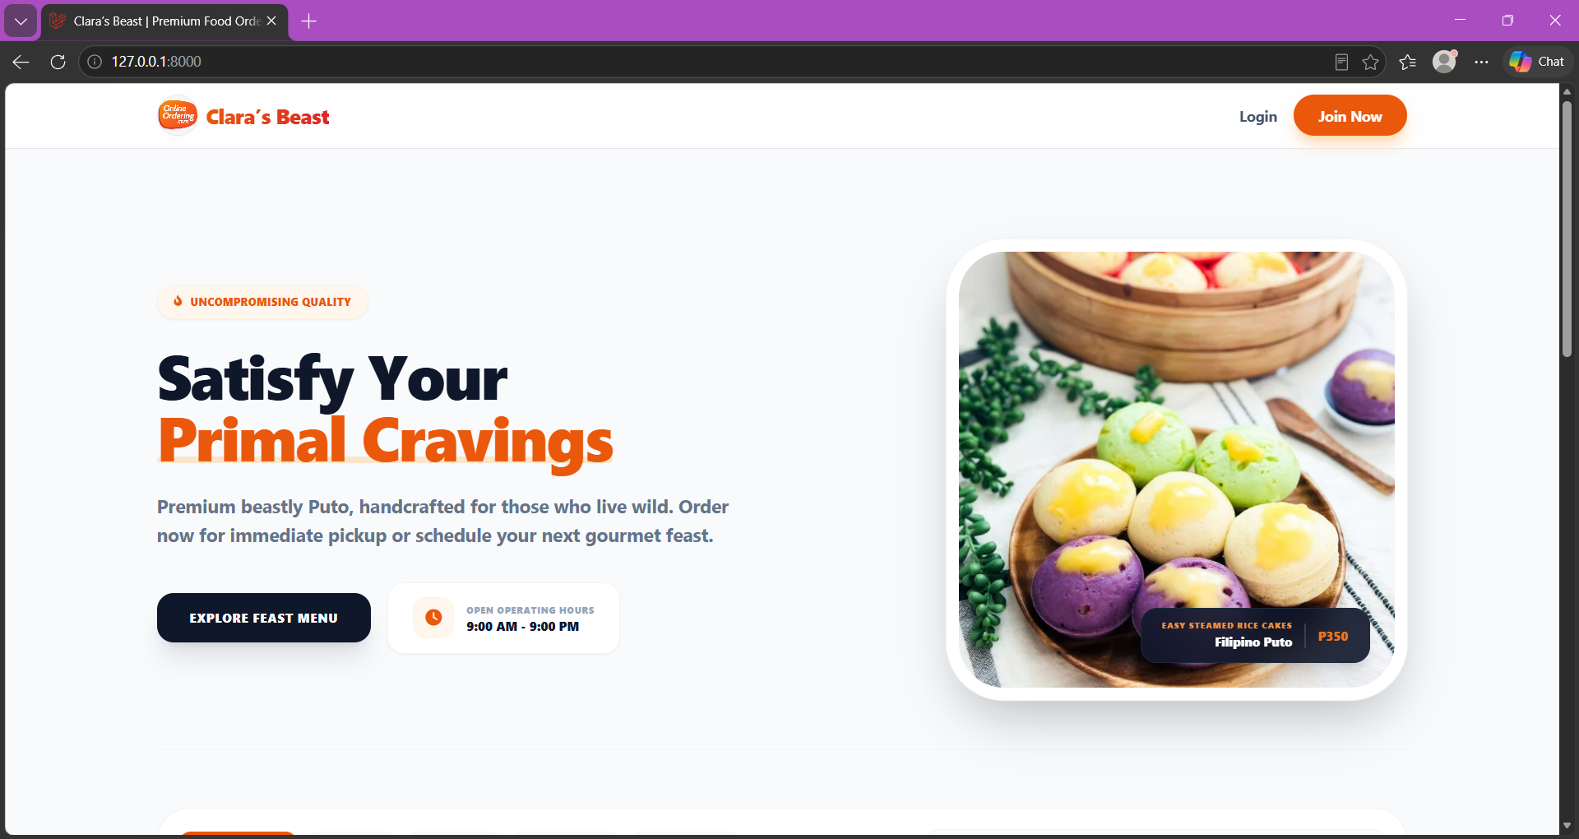
Figure 5: Home Page
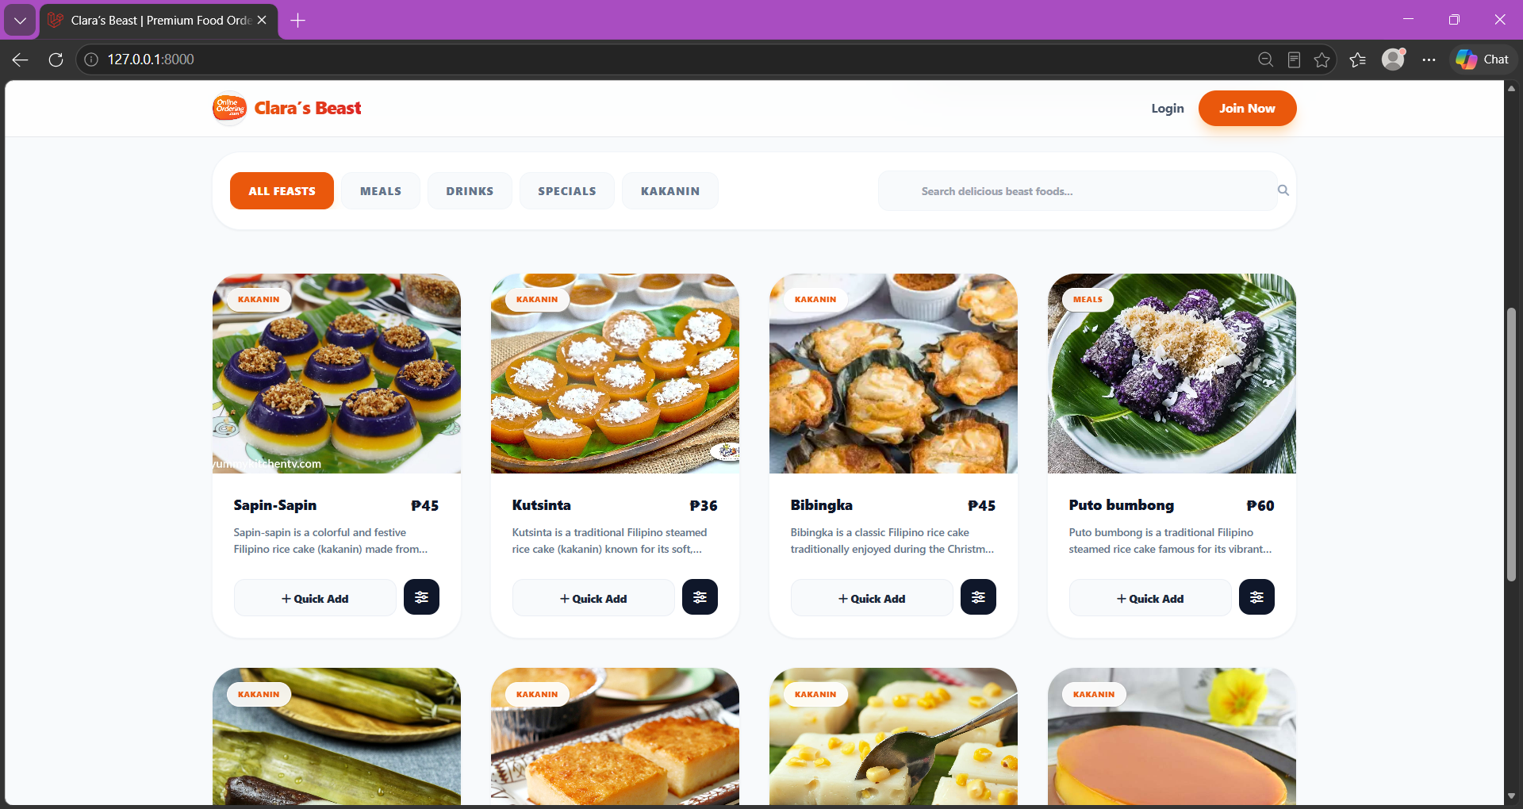
Figure 6: Menu
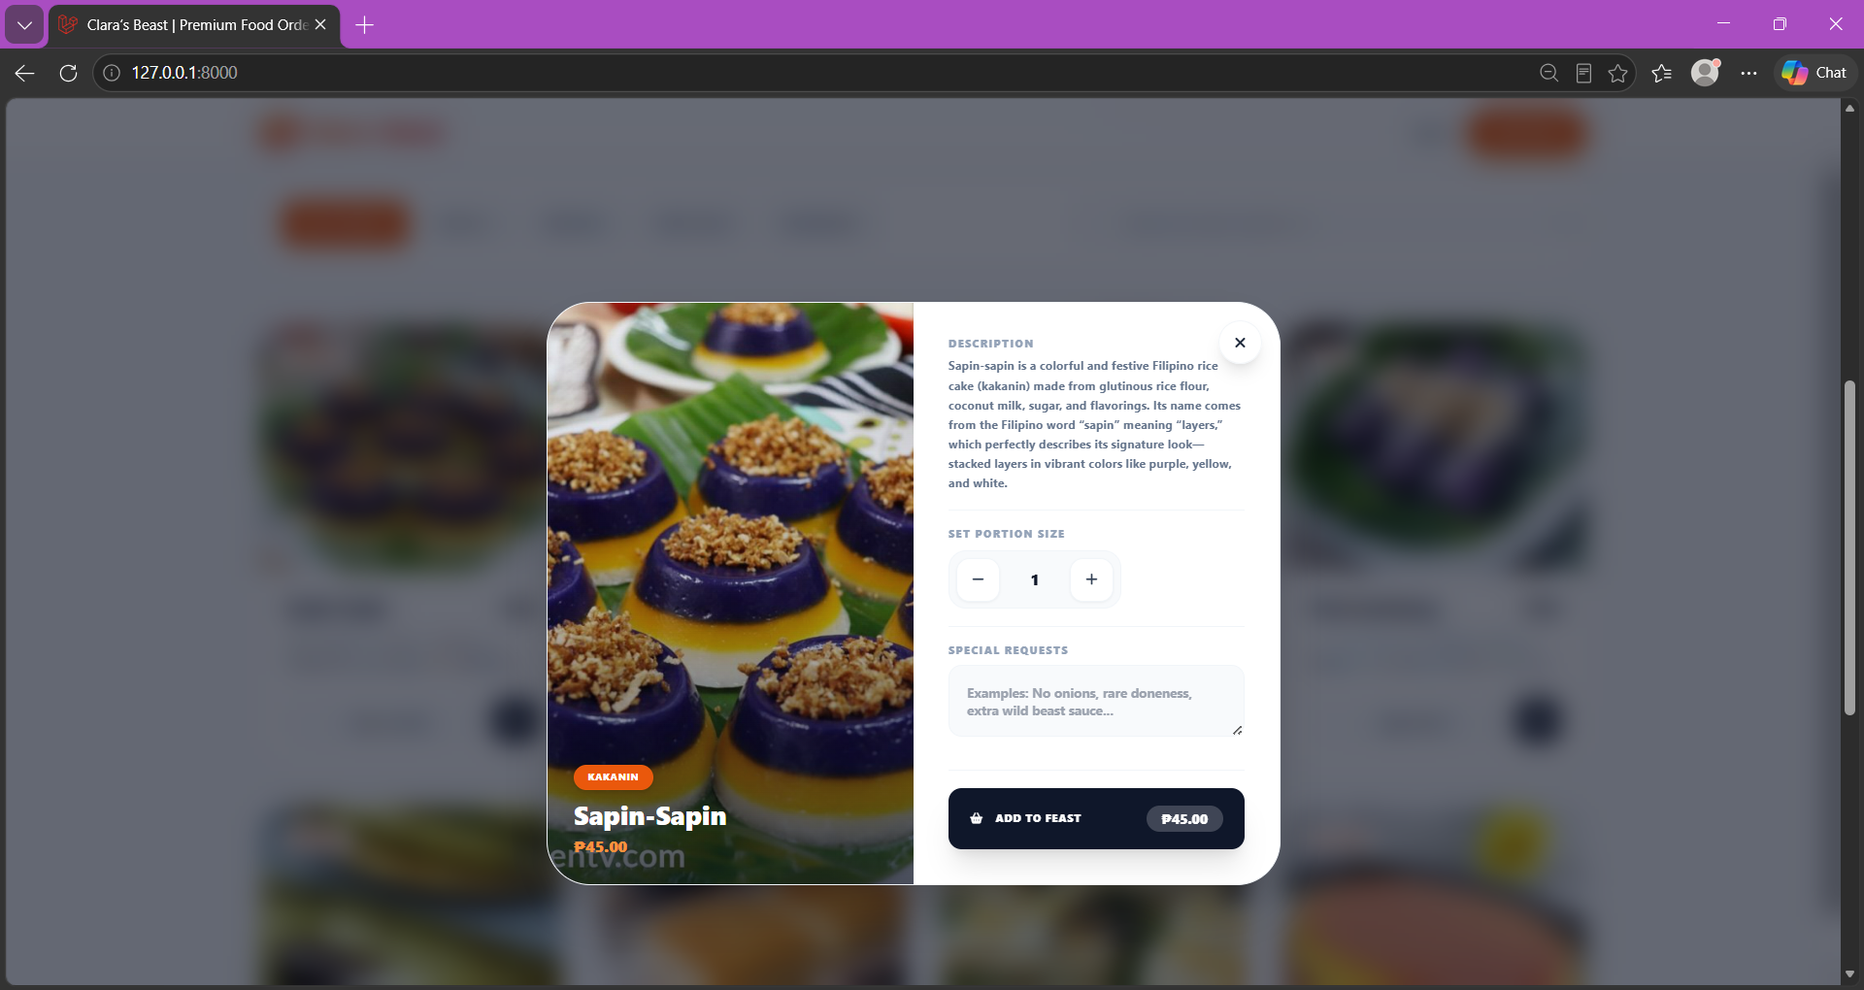
Figure 6: Menu Details
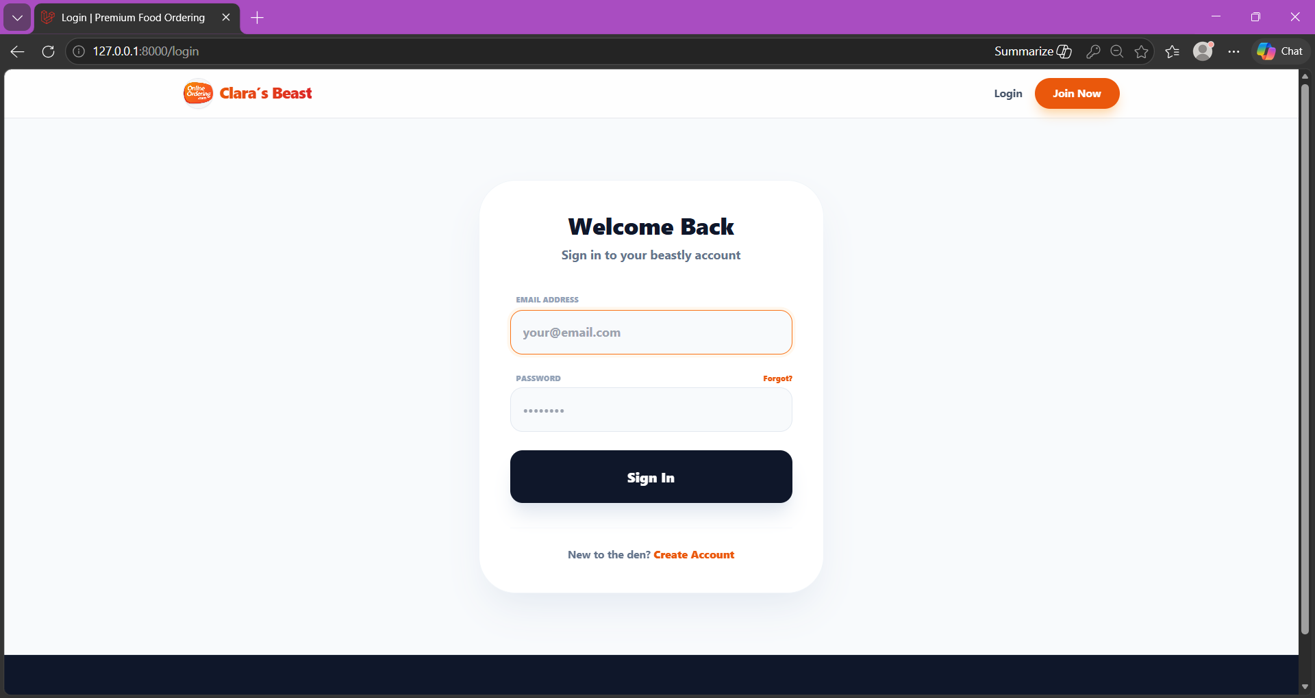
Figure 7: Login Page
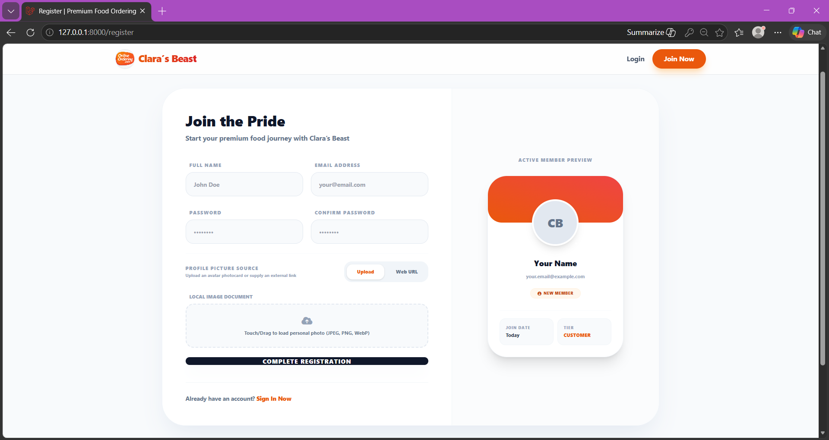
Figure 8: Register Page
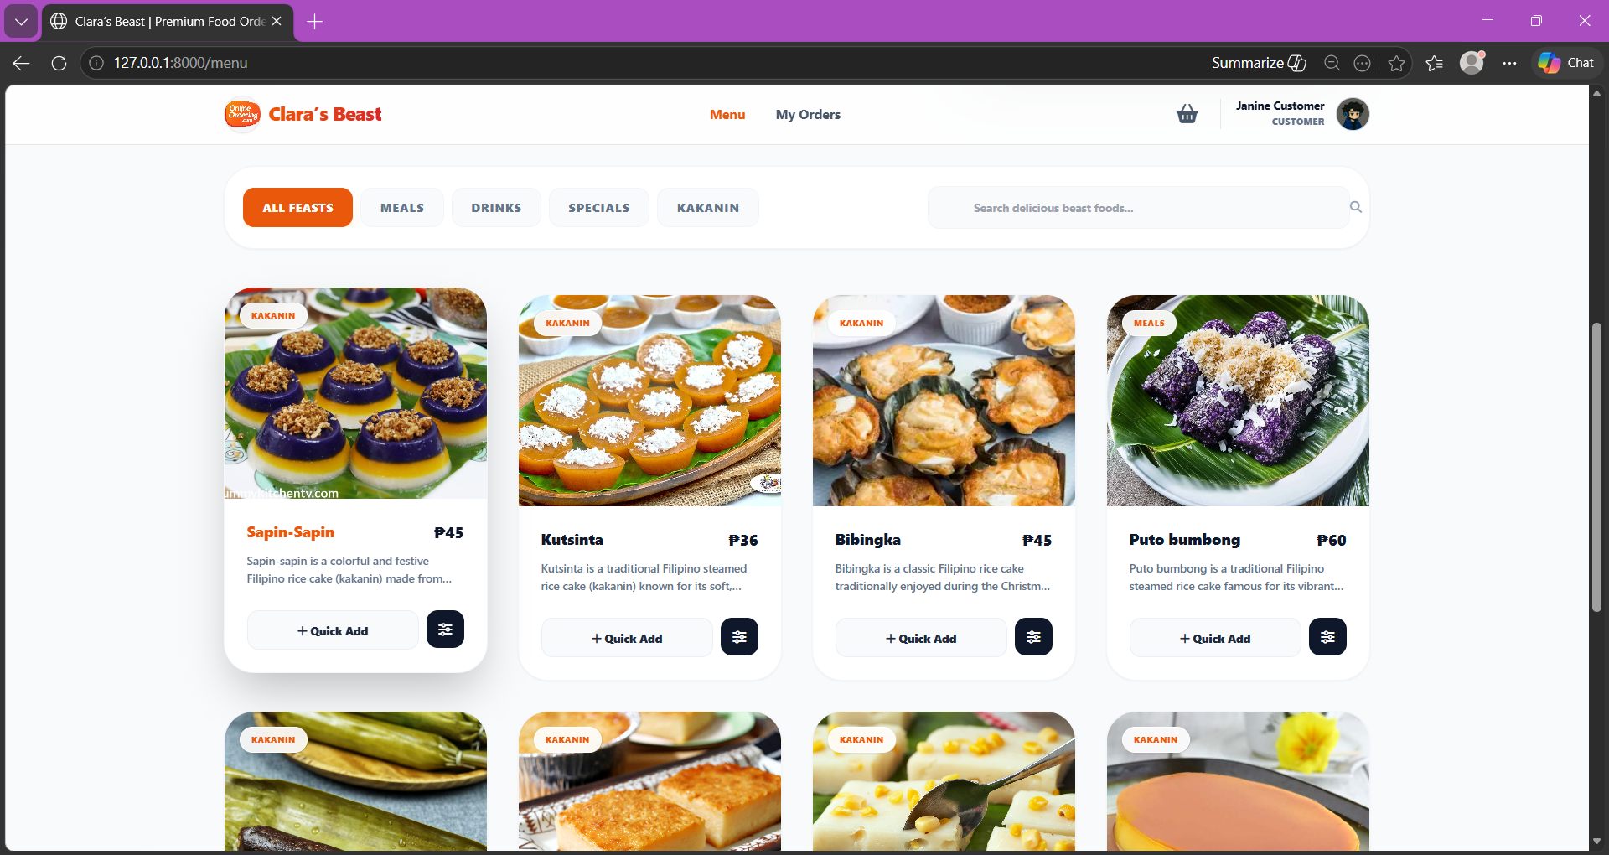
Figure 9: Customer Menu
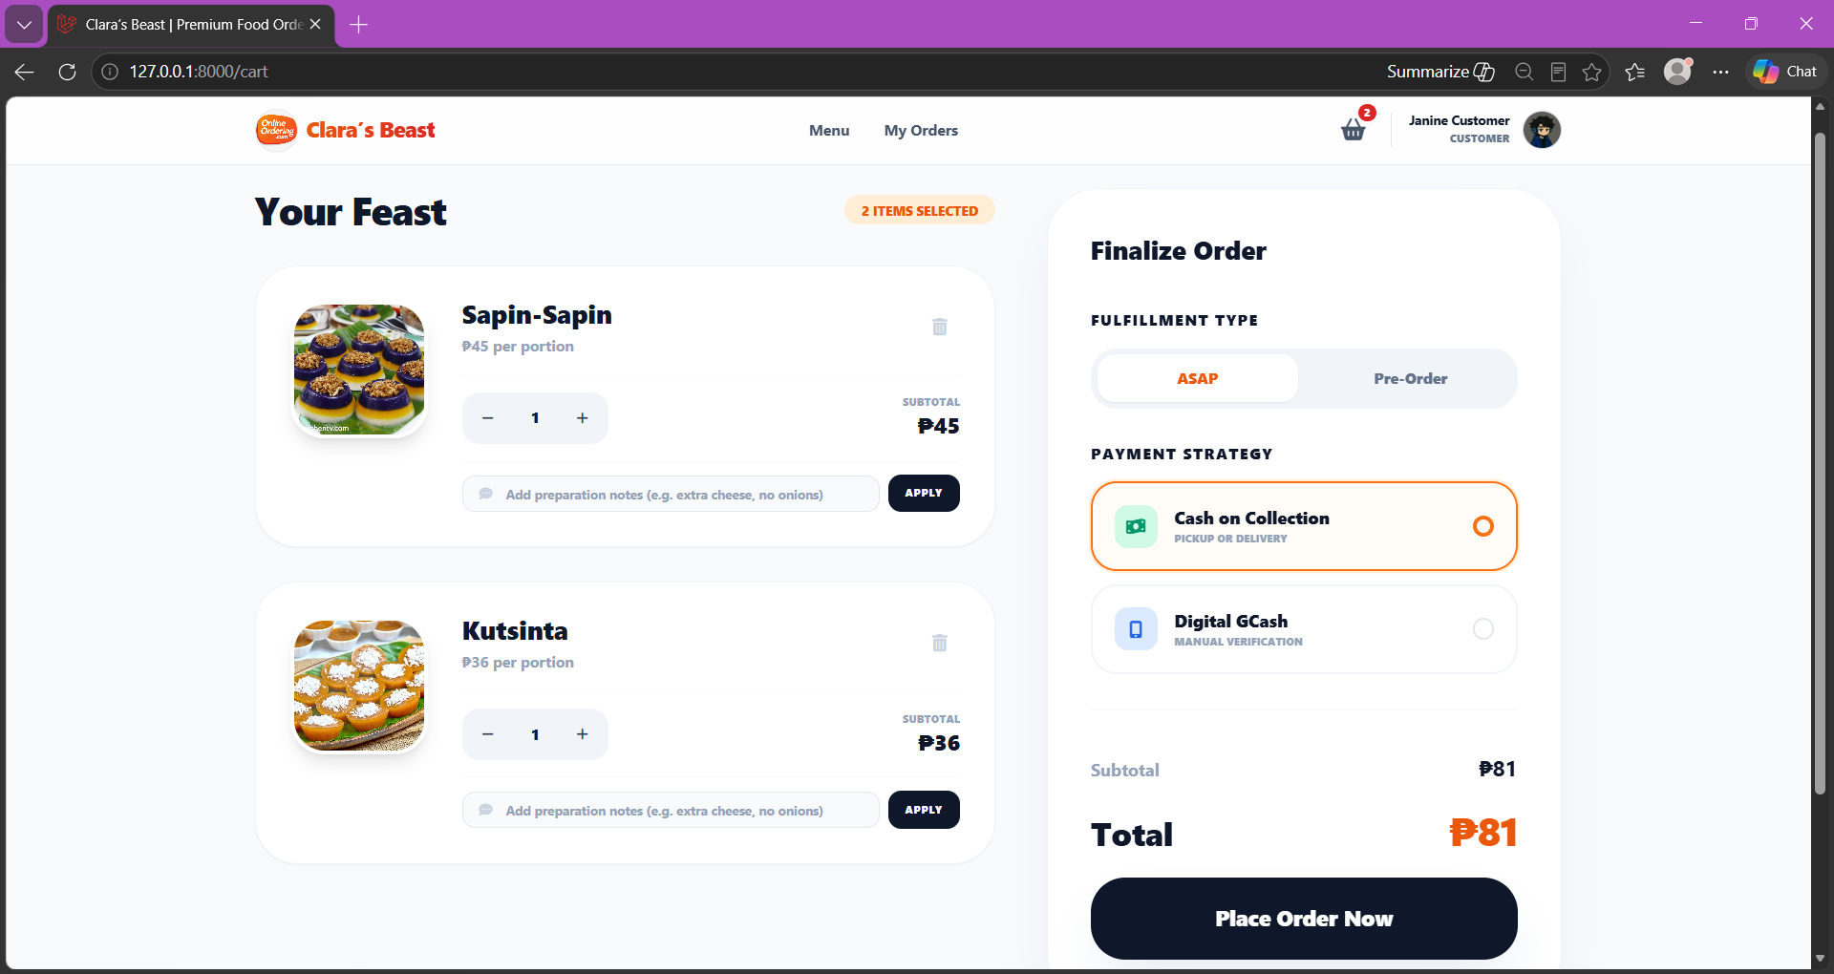
Figure 10: Customer Cart
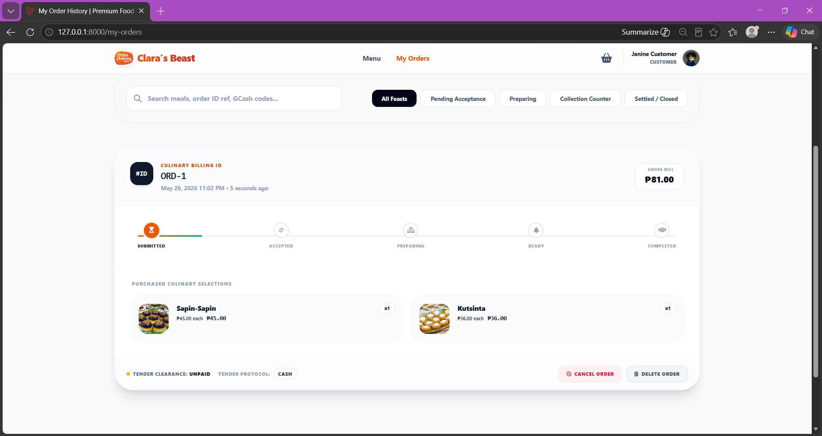
Figure 11: Customer Orders
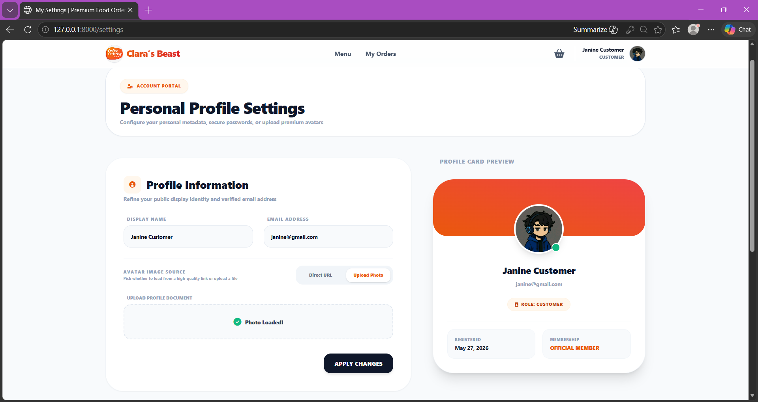
Figure 12: Customer Settings
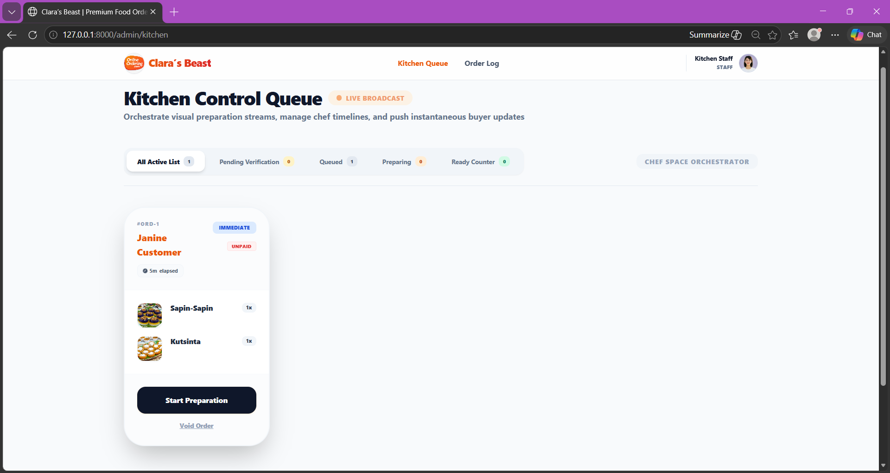
Figure 13: Staff Kitchen Queue
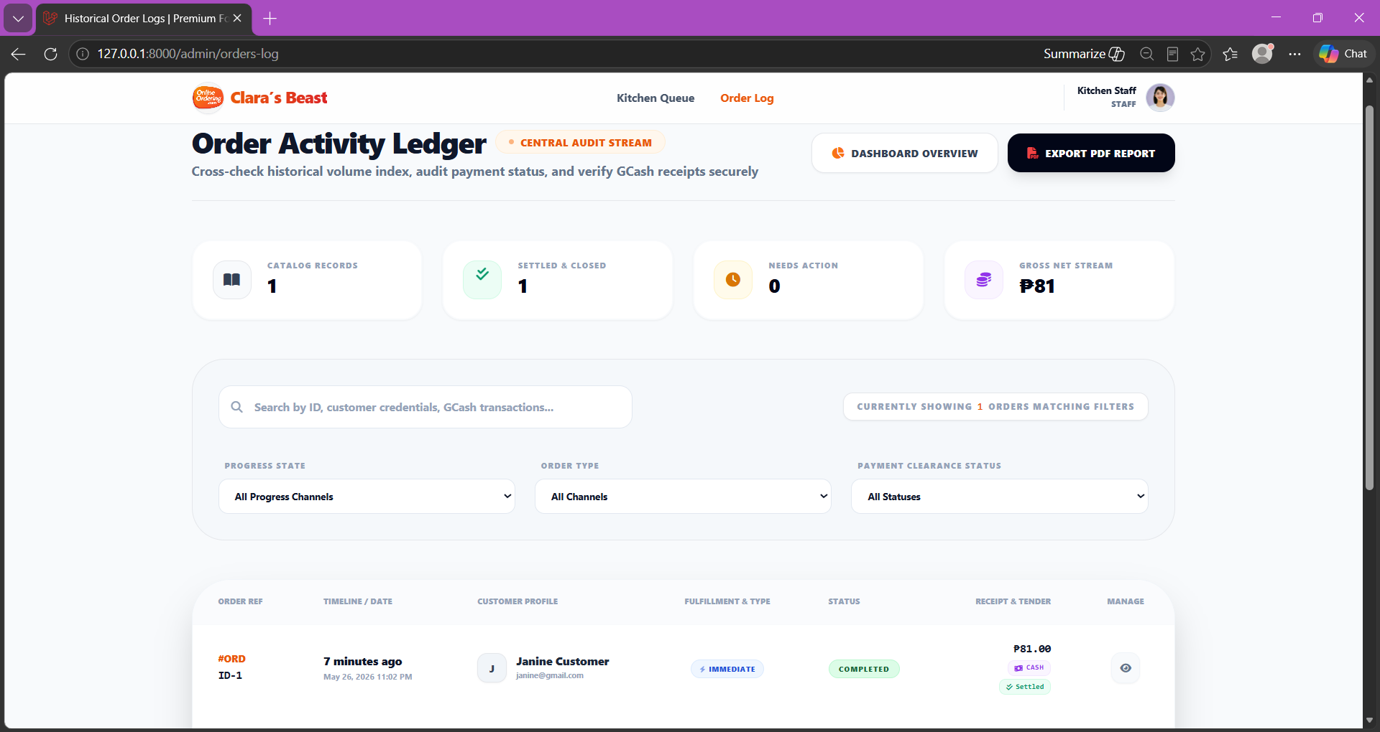
Figure 13: Staff Order Log
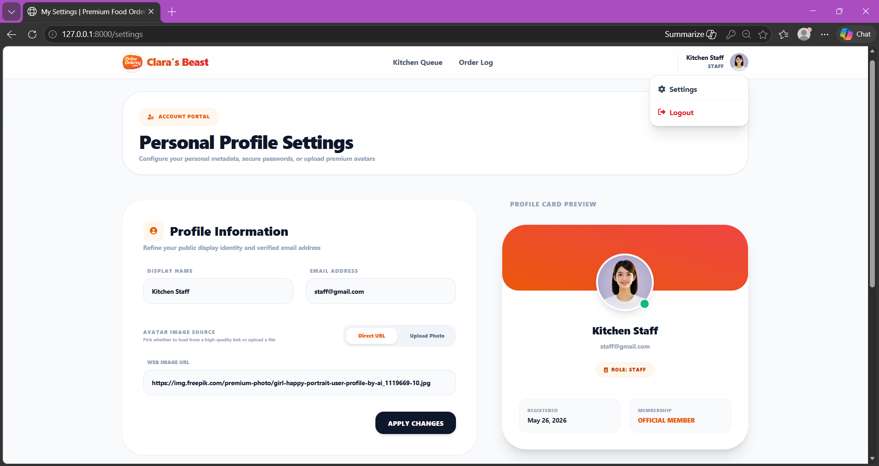
Figure 13: Staff Settings
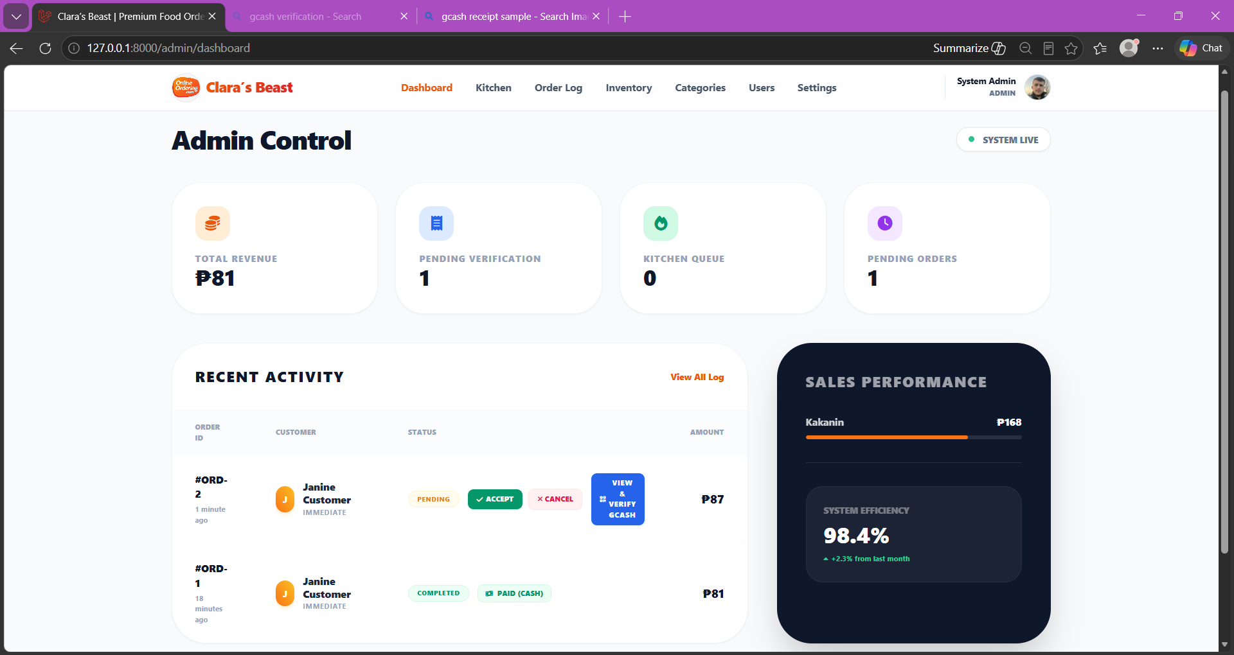
Figure 14: Admin Dashboard
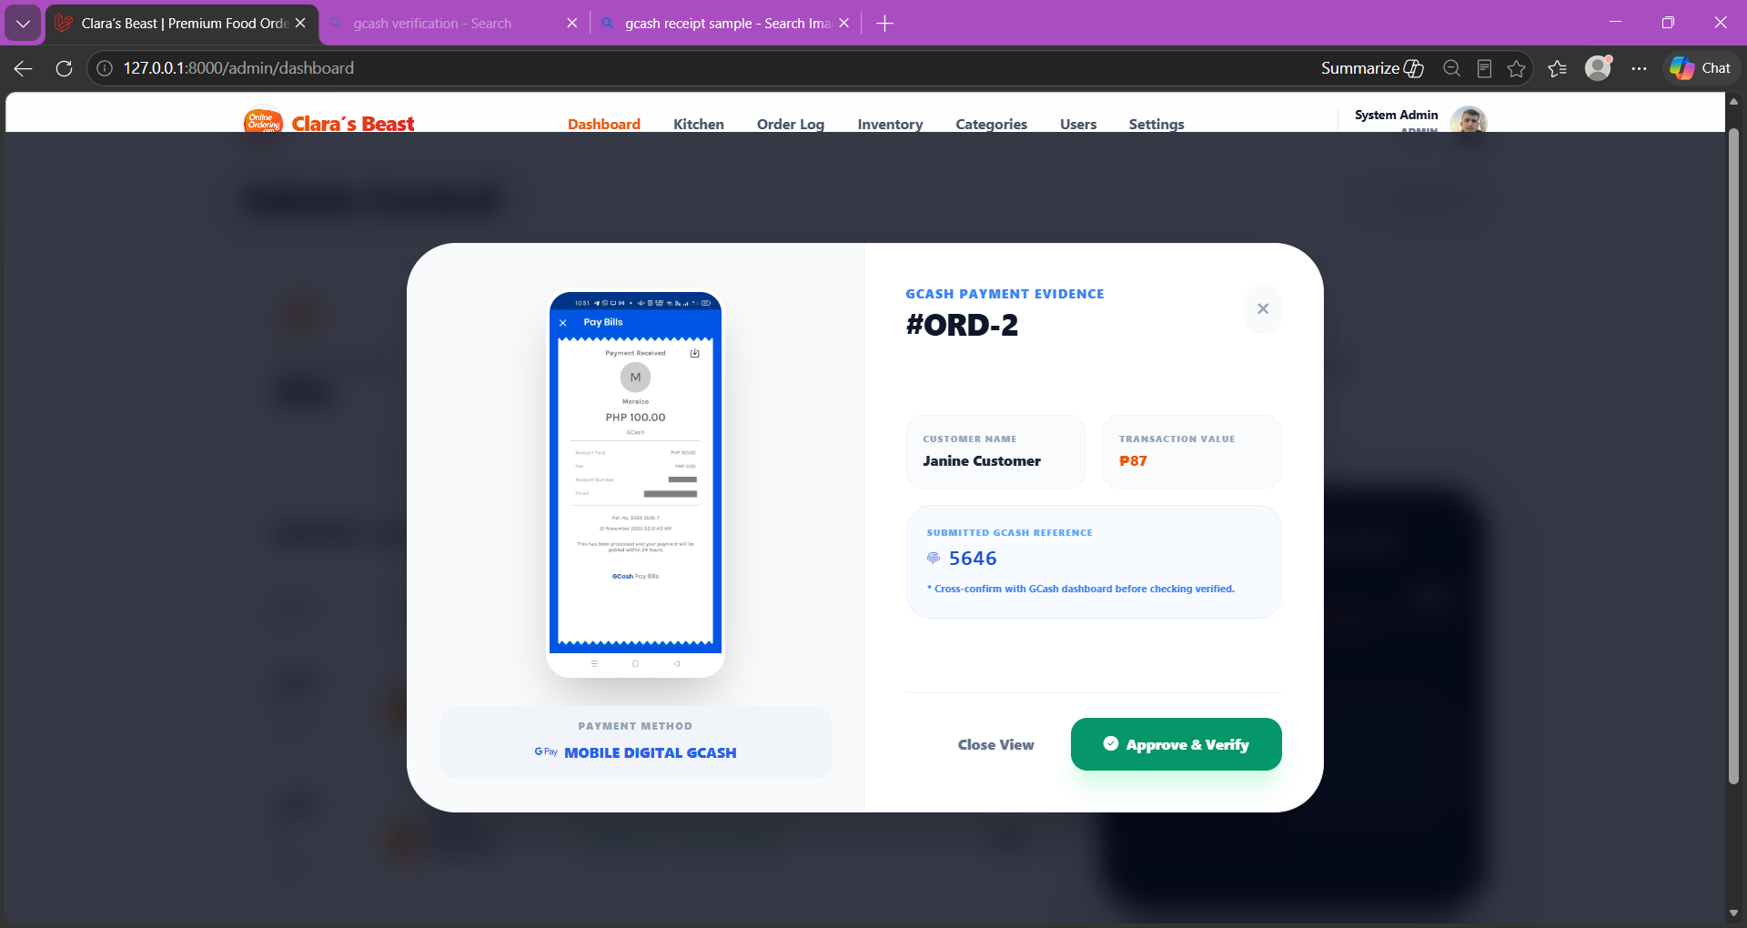
Figure 15: Admin View GCash Payment Evidence
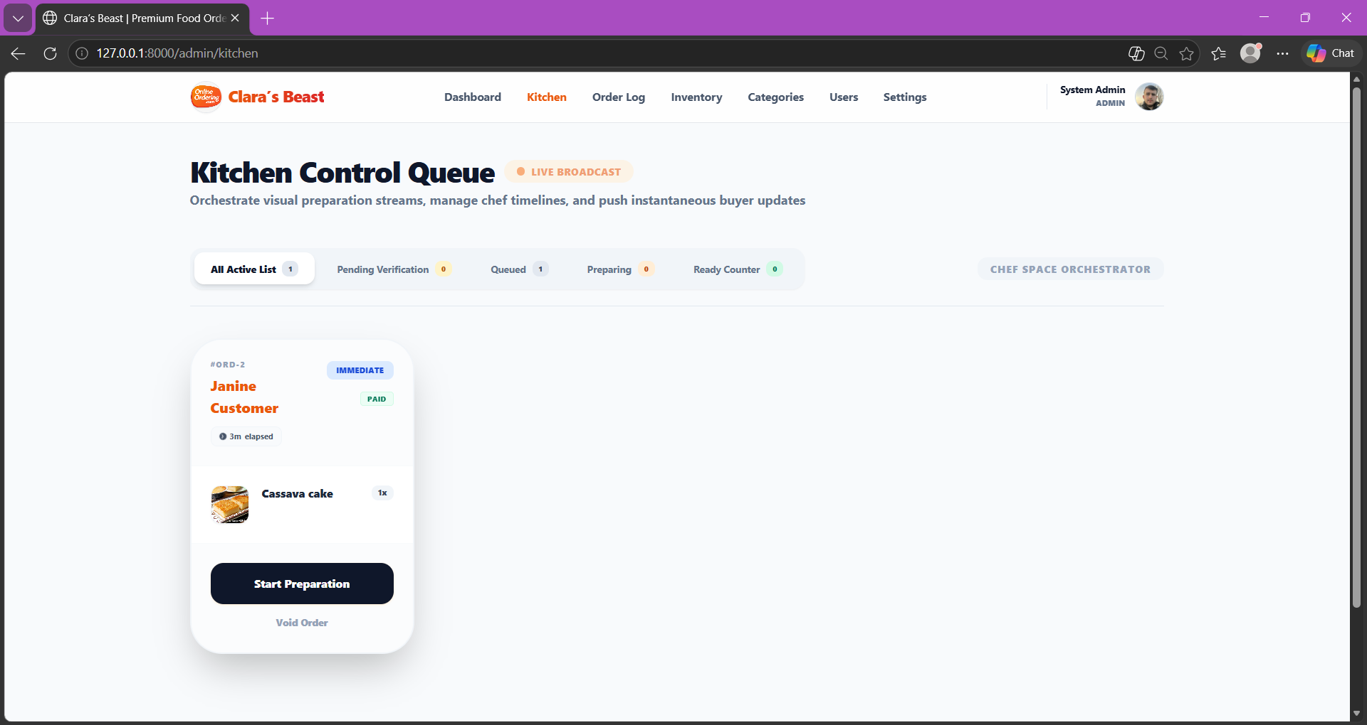
Figure 16: Admin Kitchen
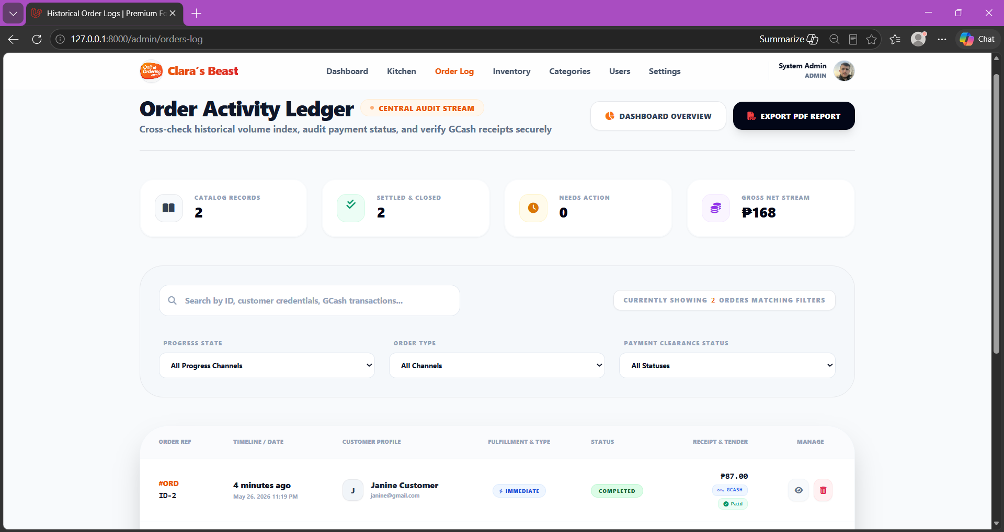
Figure 17: Admin Order Log
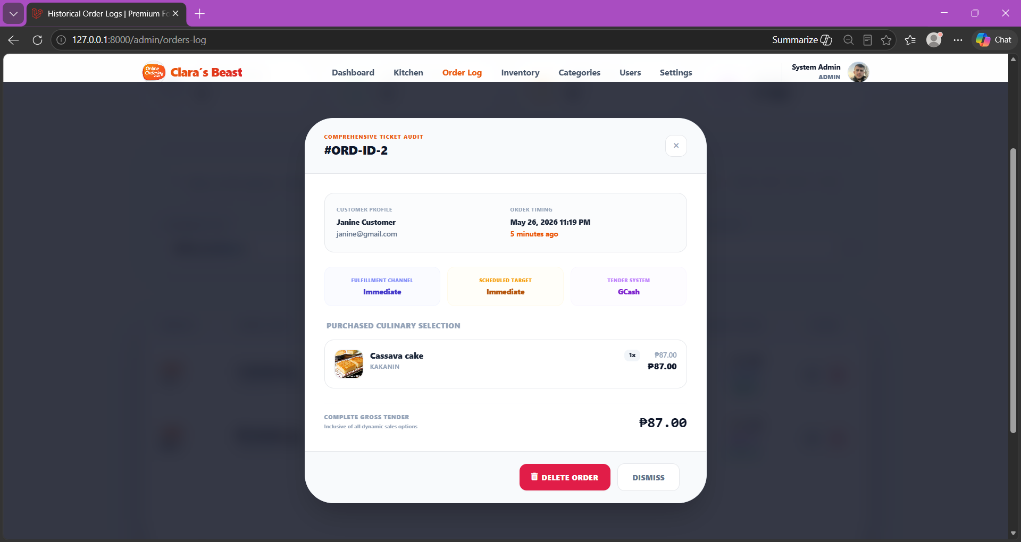
Figure 18: Admin View Order
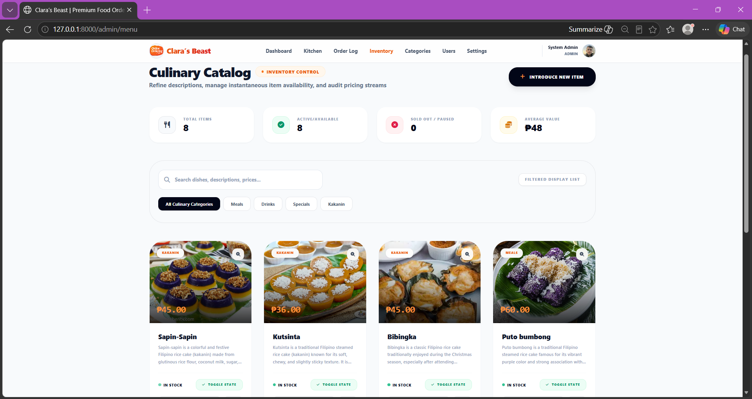
Figure 19: Admin Inventory
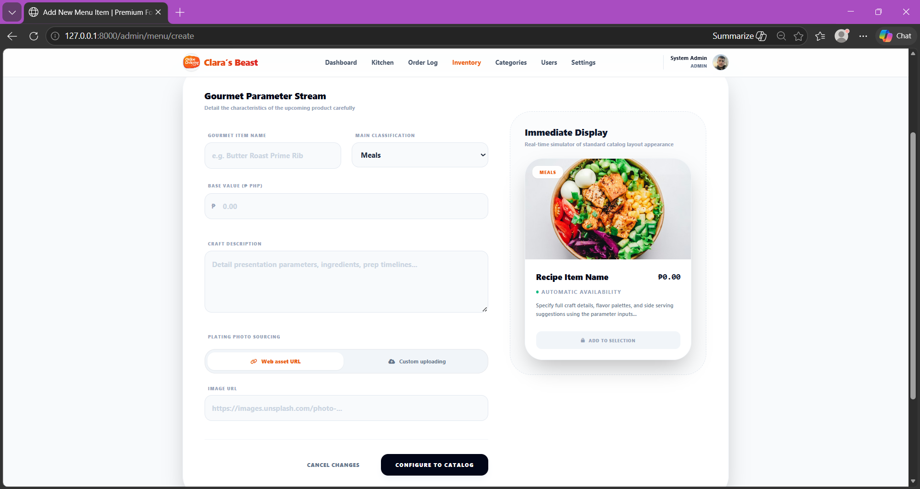
Figure 20: Admin Add menu
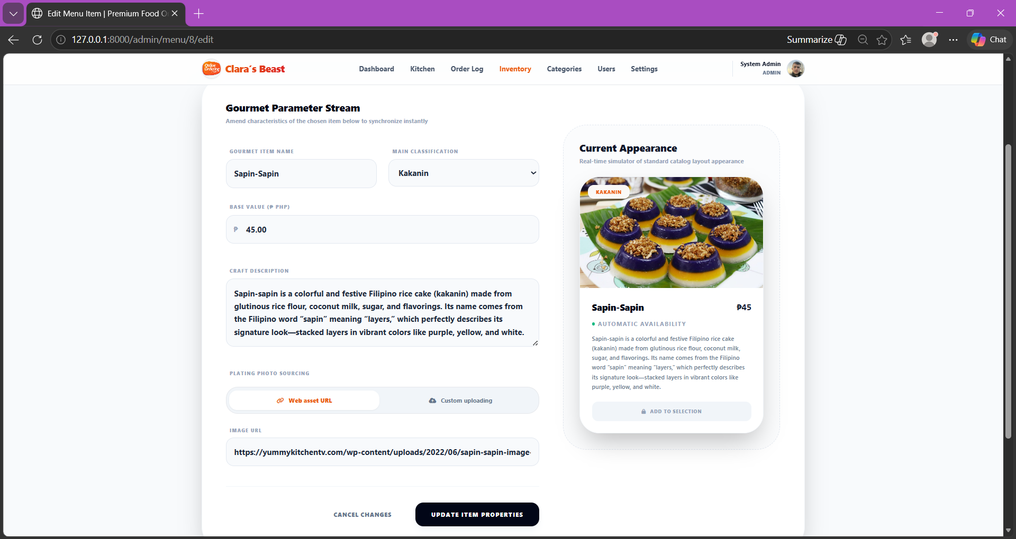
Figure 21: Admin Edit menu
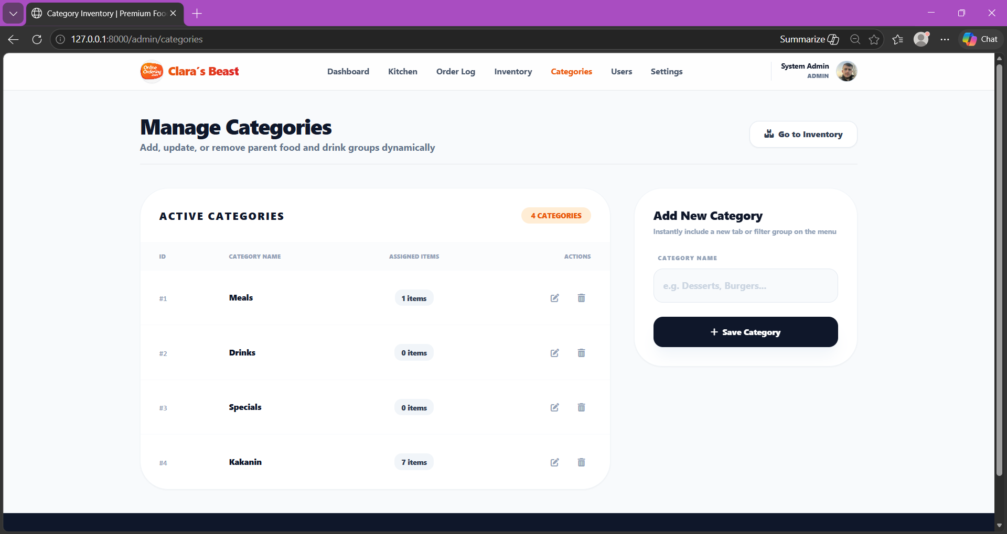
Figure 22: Admin Add Category
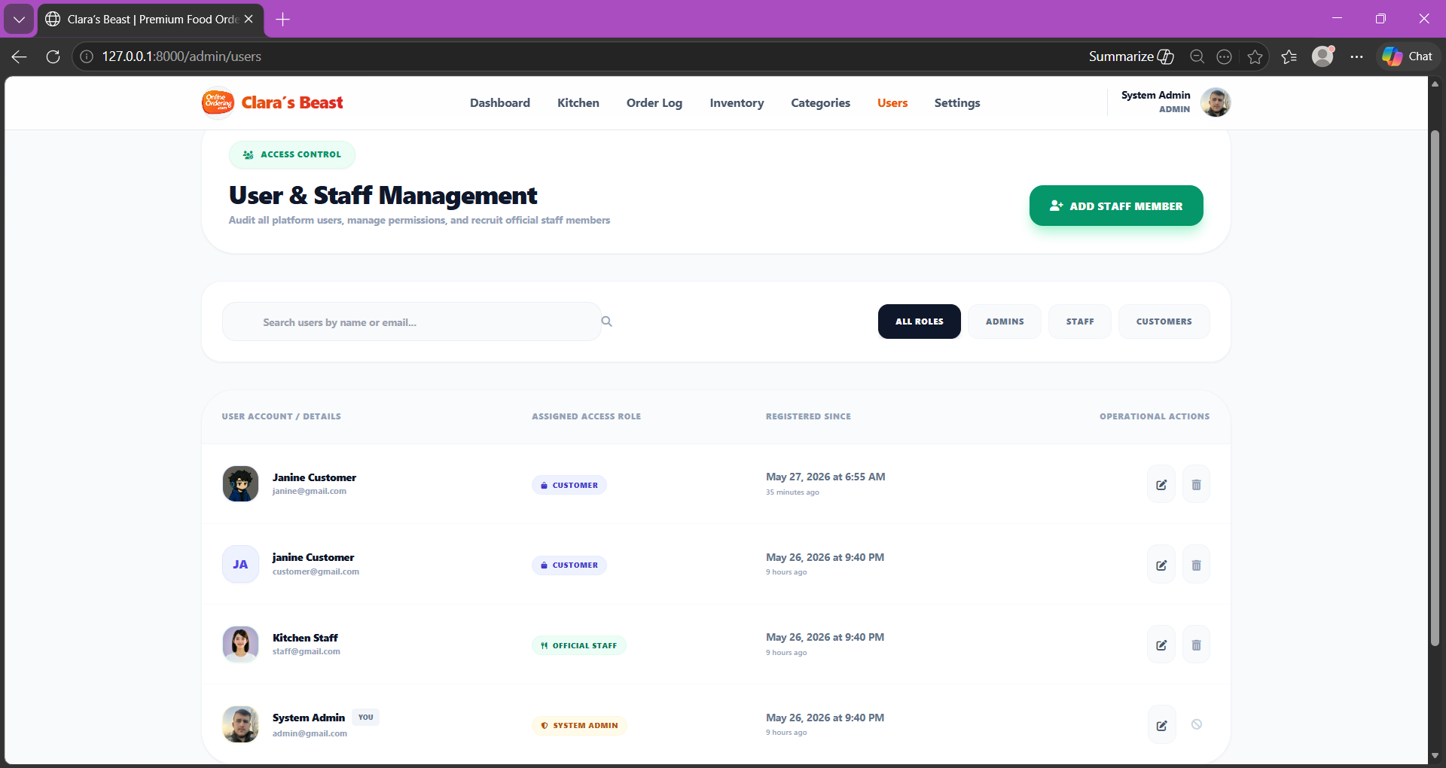
Figure 23: Admin Manage Users
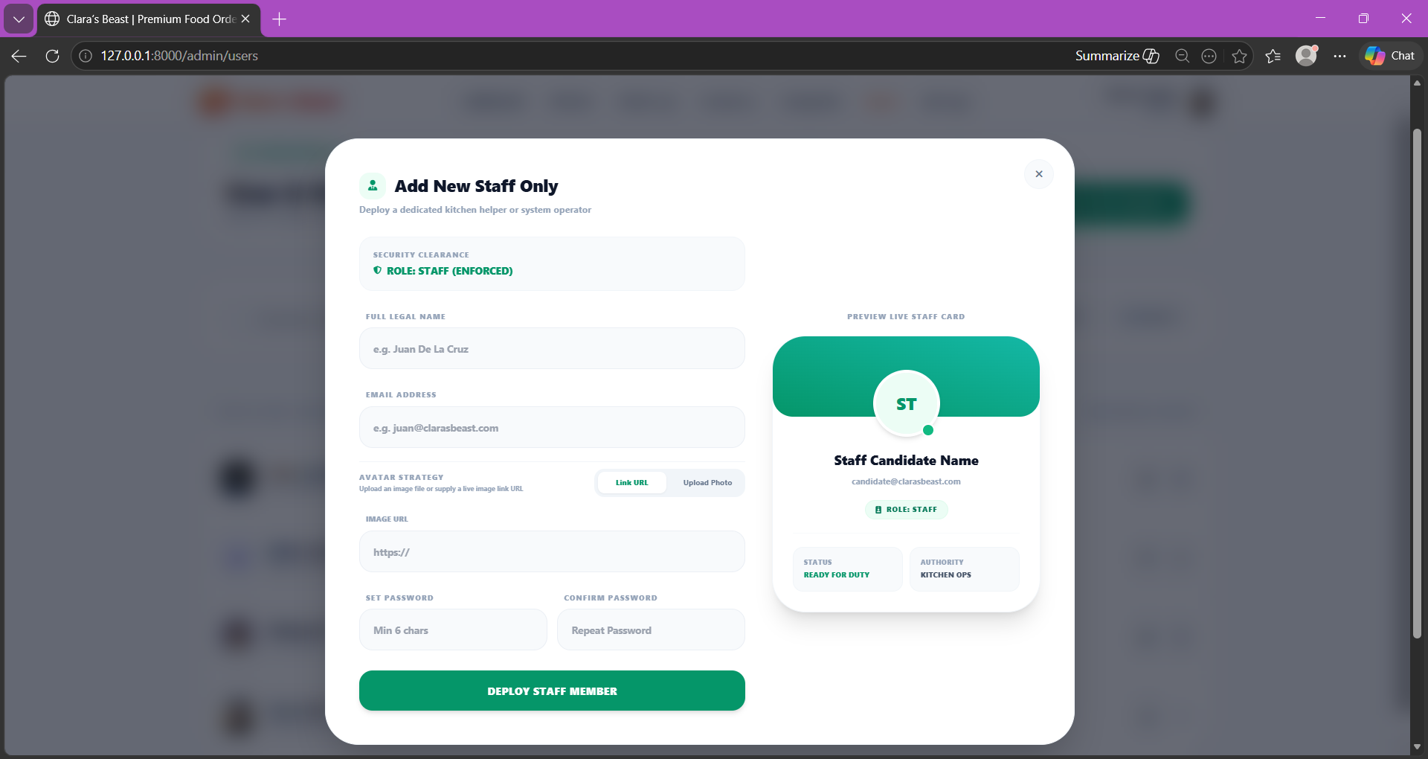
Figure 24: Admin Add Users
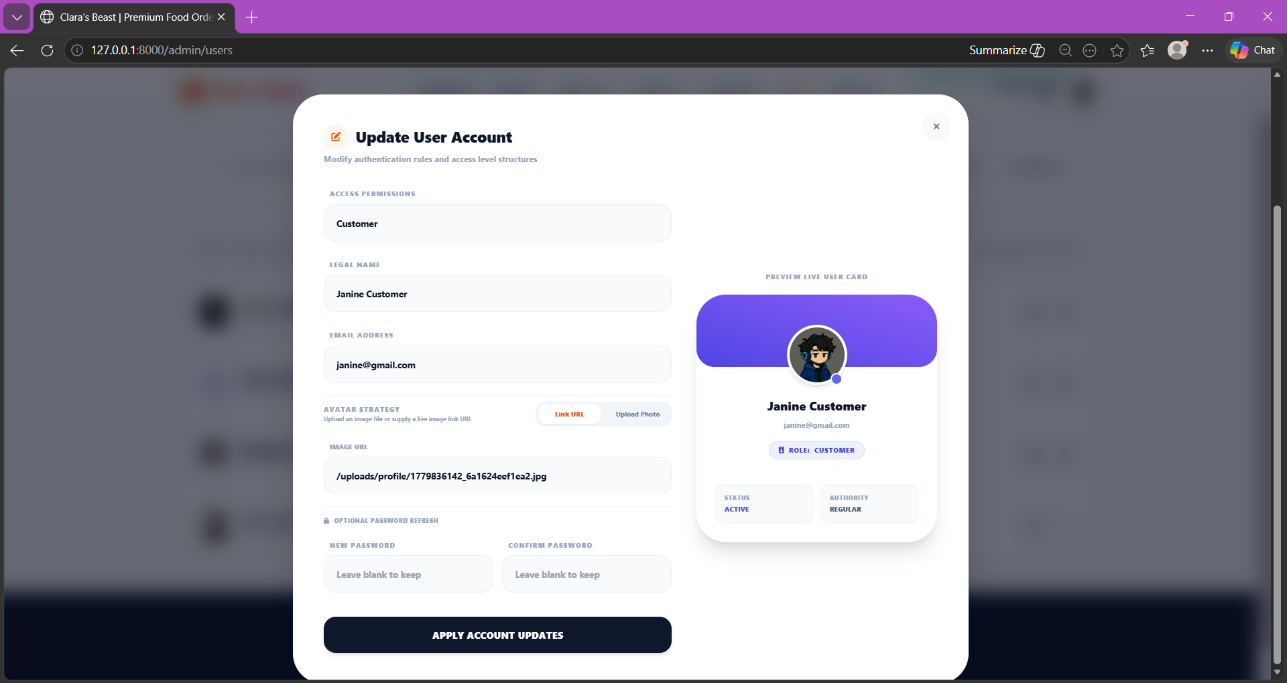
Figure 25: Admin Edit Users
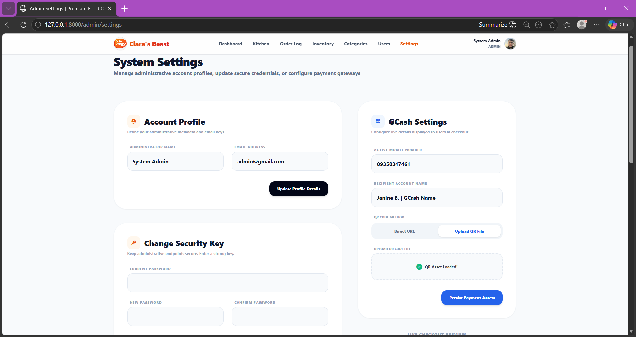
Figure 26: Admin Settings
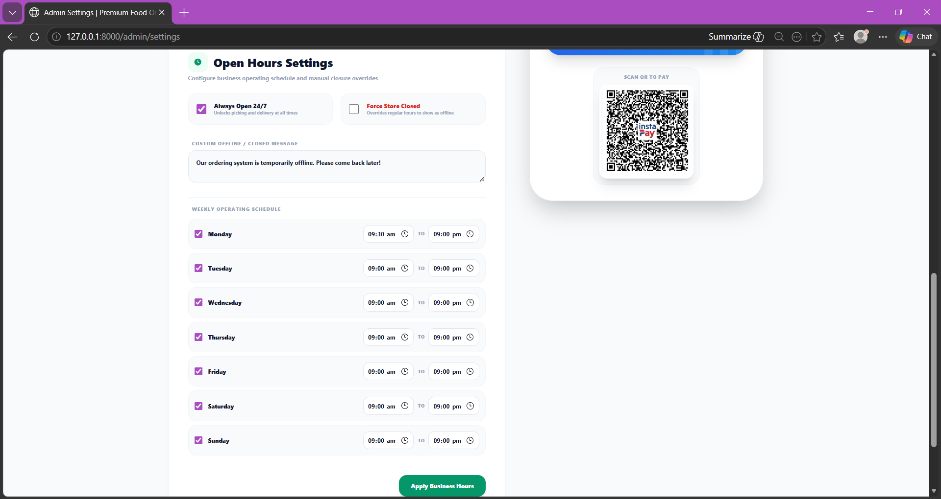
Figure 26: Admin Manage Open Hours

7. Database Structure
The following section documents the exact table schemas, data configurations, constraints, and relationships within Clara's Beast MySQL back-end migrations:

Table: users
Field | Type | Key | Nullability | Description
id | BIGINT | PK | NOT NULL | Auto-incrementing user index.
name | VARCHAR(255) | - | NOT NULL | Member's complete alphabet identifier name.
email | VARCHAR(255) | Unique | NOT NULL | Security credential electronic mailbox identifier.
email_verified_at | TIMESTAMP | - | NULLABLE | Timestamp when the email was verified.
password | VARCHAR(255) | - | NOT NULL | Hashed password credential value using bcrypt.
role | VARCHAR(50) | - | NOT NULL | Authorizations rank ('admin', 'staff', 'customer').
profile_image | VARCHAR(2048) | - | NULLABLE | Reference path to image upload or external URL.
remember_token | VARCHAR(100) | - | NULLABLE | Token for securing Laravel's "remember me" session.
created_at / updated_at | TIMESTAMP | - | NULLABLE | Standard Laravel resource tracking columns.

Table: categories
Field | Type | Key | Nullability | Description
id | BIGINT | PK | NOT NULL | Auto-incrementing category unique identifier.
name | VARCHAR(255) | Unique | NOT NULL | Descriptive name of the menu category (e.g., Starters, Meals).
created_at / updated_at | TIMESTAMP | - | NULLABLE | Standard Laravel resource tracking columns.

Table: menu_items
Field | Type | Key | Nullability | Description
id | BIGINT | PK | NOT NULL | Auto-incrementing product unique identifier.
name | VARCHAR(255) | - | NOT NULL | The printed name of the culinary option.
description | TEXT | - | NOT NULL | Detailed descriptions of portions, allergens, and ingredients.
price | DECIMAL(10,2) | - | NOT NULL | Uncapped monetary pricing for the item.
category | VARCHAR(255) | - | NOT NULL | Category string group pointer.
image | VARCHAR(2048) | - | NULLABLE | Relative storage folder reference path for the option photo.
availability_status | BOOLEAN | - | NOT NULL | Determines menu display filters (True = Available, False = Sold Out).
created_at / updated_at | TIMESTAMP | - | NULLABLE | Standard Laravel resource tracking columns.

Table: orders
Field | Type | Key | Nullability | Description
id | BIGINT | PK | NOT NULL | Auto-incrementing transaction index header number.
user_id | BIGINT | FK | NOT NULL | Links user ID record in users table; updates cascade.
total_amount | DECIMAL(10,2) | - | NOT NULL | Billing statement final calculated payout cost.
order_type | VARCHAR(50) | - | NOT NULL | Fulfillment mode: 'Immediate' or 'Scheduled'.
scheduled_datetime | DATETIME | - | NULLABLE | Fulfillment target timestamp for scheduled pre-orders.
status | VARCHAR(50) | - | NOT NULL | Fulfillment status workflow phase: (Pending, Confirmed, Preparing, Ready, Completed, Cancelled).
payment_method | VARCHAR(50) | - | NOT NULL | Fulfillment checkout option ('Cash', 'GCash').
payment_status | VARCHAR(50) | - | NOT NULL | Clearance status of the order transaction ('Unpaid', 'Pending Verification', 'Paid', 'Failed').
created_at / updated_at | TIMESTAMP | - | NULLABLE | Standard Laravel resource tracking columns.

Table: order_details
Field | Type | Key | Nullability | Description
id | BIGINT | PK | NOT NULL | Auto-incrementing sub-line transaction item.
order_id | BIGINT | FK | NOT NULL | Binds parent invoice record in orders table; cascading.
menu_item_id | BIGINT | FK | NULLABLE | Binds chosen menu option references; preserves as null if menu item is deleted from system roster.
quantity | INTEGER | - | NOT NULL | Number of ordered portions (capped under system buffer limits).
subtotal | DECIMAL(10,2) | - | NOT NULL | Line subtotal cost before order-level modifiers.
special_instructions | TEXT | - | NULLABLE | Custom notes for dietary requirements or preferences.
created_at / updated_at | TIMESTAMP | - | NULLABLE | Standard Laravel resource tracking columns.

Table: payments
Field | Type | Key | Nullability | Description
id | BIGINT | PK | NOT NULL | Auto-incrementing payments identifier.
order_id | BIGINT | FK | NOT NULL | Relational parent linking to orders; cascaded.
payment_method | VARCHAR(255) | - | NOT NULL | Method selected by user (Cash, GCash).
amount | DECIMAL(10,2) | - | NOT NULL | Amount transacted in local currency PHP.
payment_status | VARCHAR(255) | - | NOT NULL | Status of this payment ledger entity.
reference_number | VARCHAR(255) | - | NULLABLE | Unique 13-digit code representing electronic money receipt reference.
proof_image | VARCHAR(2048) | - | NULLABLE | File path pointing to the receipt proof PNG or JPG upload (restricted to 5MB).
verified_by | BIGINT | FK | NULLABLE | References user ID of the Admin/Staff member who validated the receipt.
created_at / updated_at | TIMESTAMP | - | NULLABLE | Standard Laravel resource tracking columns.

Table: password_reset_tokens
Field | Type | Key | Nullability | Description
email | VARCHAR(255) | PK | NOT NULL | User mailbox identifying token request.
token | VARCHAR(255) | - | NOT NULL | Security signature hash validation sequence.
created_at | TIMESTAMP | - | NULLABLE | Timestamp when the reset token request was initialized.

Table: sessions
Field | Type | Key | Nullability | Description
id | VARCHAR(255) | PK | NOT NULL | Dynamic string identifier matching secure cookie values.
user_id | BIGINT | Index | NULLABLE | Points to signed-in user's PK; blank for unauthenticated guests.
ip_address | VARCHAR(45) | - | NULLABLE | Network source protocol address of browser socket connection.
user_agent | TEXT | - | NULLABLE | Browser user-agent representation header.
payload | LONGTEXT | - | NOT NULL | Serialized session key-value storage buffer block.
last_activity | INTEGER | Index | NOT NULL | Unix epoch timestamp representing user's last interactive ping.

8. Implementation and Testing
8.1 Agile System Development Process
The development structure of Clara’s Beast followed custom agile sprints. Phase 1 comprised scaffolding the relational migrations and user authorization sessions. Phase 2 engineered the product catalog grouping views and the AlpineJS cart container. Phase 3 introduced high-utility profile settings, profile picture upload routines, and manual file movement limits. In Phase 4, the kitchen status controller state triggers and GCash receipt uploading screen was hardened against validation failures.
8.2 Testing Procedures and Validation Logs
High-fidelity boundary condition testing was executed thoroughly:
- Test Code TC-01 (Avatar Upload Limit Check): Selecting a profile image of 18 Megabytes triggered Laravel validation errors as intended, restricting server storage strain and prompting with active rules.
- Test Code TC-02 (Date validation checks): Picking a retro date or the current timestamp for scheduled pre-order checkout triggers an instantaneous AlpineJS client warning banner.
- Test Code TC-03 (State limits cancel test): Customer tries to cancel order while kitchen status is in "Preparing" state. The server halts process, throws an HTTP 403 / warning redirect, and preserves store records.
- Test Code TC-04 (Cart portion index cap): Inputting a negative shopping cart quantity or exceeding 100 portion units correctly defaults and prompts users to keep units inside standard safe bounds.

9. Conclusion
In retrospect, the System design project developed across the semester for Clara’s Beast: A Premium Food Ordering System successfully achieved all primary and specific system objectives. By creating digital customer profiles with secure avatar uploading, construction of a responsive React-like instant cart, formulation of a dynamic five-tier kitchen status tracking queue, and visual transaction checking logs, the system eliminates administrative delivery delays.
The benefits of this application rest in transforming raw operational miscommunication. Kitchen technicians obtain real-time order lists instantly, customers monitor active bookings directly, and store owners balance payment receipts visually via GCash audit dashboards. Development of this program built rich engineering lessons: integrating AlpineJS state parameters with backend database schemas, executing file system move rules securely, and wrapping components cleanly so user interfaces look modern and polished.

10. Recommendations
While the current monolithic release of Clara's Beast operates robustly, future improvements can expand transactional security and customer joy across subsequent semesters:
- E-Wallet API integration: Establish live webhook callbacks matching GCash or PayMaya sandboxes for automated ledger updates without manual verification delays.
- Dynamic SMS Gateway alerts: Hook systems into SMS delivery triggers (e.g. Twilio or Infobip) to alert customers on instant ready-to-collect statuses.
- GPS rider tracking: Introduce Google Maps Platform geolocation SDK vectors to display driver locations in real-time.
- AI Analytics Core: Add model recommendation layers to suggest seasonal recipe bundles, optimizing store sales.

